Cheesy Cauli-Blues
Inspired by


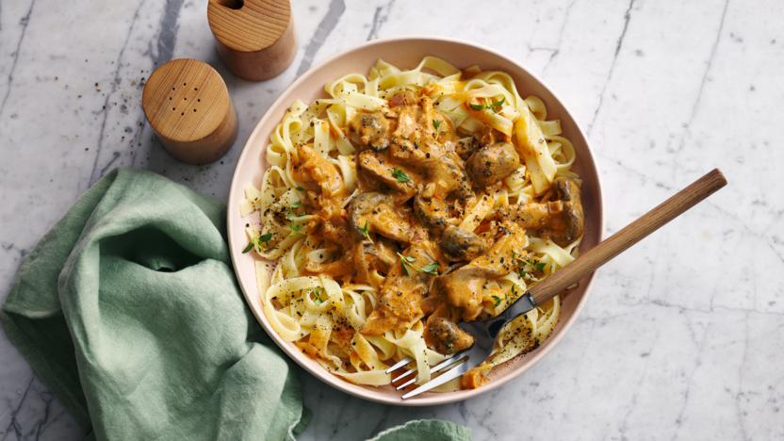
DID YOU KNOW?
“Mac & Cheese has been enjoyed for centuries, thought to have been first created in the 13th century in an Italian cookbook. What do you think of our take on the all-time classic?”

Ingredients
200g of Macaroni (or pasta of your choice)
4 tbsp of olive oil
60g of mature cheddar cheese
30g of blue cheese
25g of breadcrumbs
300g of cauliflower
2 tbsp plain flour
250ml of water
1 vegetable stock
150g Oatley cream
100g of baby spinach

Nutrition – Total / Per Serving
Calories: 1700kcal / 850kcal
Carbohydrates: 146g / 73g
Protein: 41g / 20.5g
Fat: 96g / 48g
Fibre: 9g / 4.5g
Sugar: 14g / 7g






Good for:

Star Rating:





Method


Step 1 - Preparation
Boil the kettle.
Preheat the oven to 220°c.
Grate the cheddar cheese and add to a bowl.
Add the blue cheese and breadcrumbs to the same bowl.
Season with salt & pepper.
Stir in 2 tbsp of olive oil and set aside.
Cut the cauliflower into small florets.

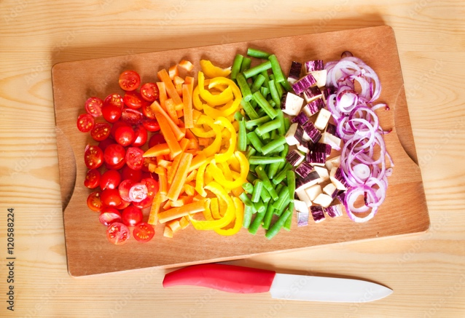

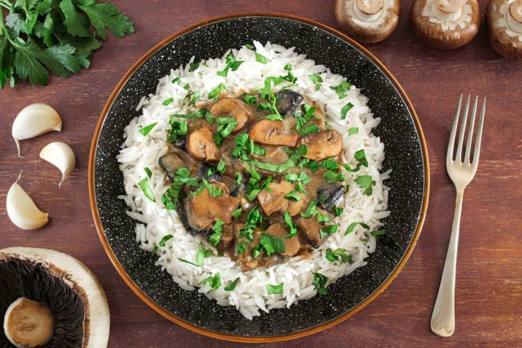
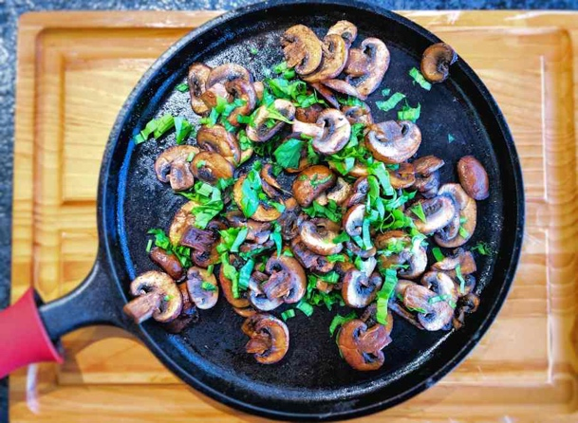
Sam’s top tip:
Serve with a drizzle of sriracha.
Step 4 – Bring it Together
Remove the cauliflower from the oven and mix the pasta into it.
Stir the cheese sauce into the oven dish.
Sprinkle the blue cheese and breadcrumb mix on top.
Place back in the oven until the crumb is golden (~5 mins)
Remove from the oven and serve.

Enjoy!
Step 3 – Make it Saucy
In another saucepan, heat 2 tbsp of oil.
Once the oil is hot, add in the flour and stir until it forms a paste.
Gradually add in the water to the paste along with the vegetable stock. Bring to a boil.
Stir and simmer until the sauce has thickened. (~2mins)
Stir in the cream and remove from the heat.
Add the cheddar cheese to the pan and stir until melted.
Return the pan to the heat and add in the spinach.
Once the spinach has wilted, remove from heat.
Step 2 – Cook & Roast
Cook the pasta according to the package instructions. (once cooked, drain the pasta)
Put the cauliflower into an ovenproof dish and drizzle oil over the top. Season with salt & pepper to taste.
Put in the oven until golden brown. (~15-18 mins)

